This leaflet has been written for parents who are thinking of arranging an Infant Blessing for their child at Over United Reformed Church.
It seeks to explain the significance of Infant Blessing,
the promises that are made and the responsibilities
of the parents and Godparents.

INFANT BLESSING
The service of Infant Blessing gives parents the opportunity to come into church, express their gratitude for the gift
of their child, dedicate themselves as parents, and commit themselves to the responsibilities of parenthood.

During the service they are assured of God’s constant love for their child, and his love for them as parents.

GODPARENTS
When you decide to seek Infant Blessing for your child, you can invite certain special people to be Godparents. These should be chosen very carefully. They should be people in whom you have confidence and trust. They need to be people who will be a friend to your child throughout the years. People who will love, support and encourage your child as he or she grows up, right on into adult life.

Traditionally, there are two Godparents of the same sex as the child and one of the opposite sex. Sometimes parents will choose two couples to be Godparents, providing the child with four Godparents.

Here are the promises made at an Infant Blessing.
PROMISES AT INFANT BLESSING

Parent’s Promises
Do you thank God, the source of all life,
for the gift of your child?
We do
“Do you, in the presence of God, dedicate yourselves as (child’s name) parents, and commit yourselves to fulfilling
the responsibilities of parenthood?”
With God’s help we do.
Do you promise, with God’s help,
to so live your lives that (child’s name)
will be surrounded by love and goodness?
With God’s help we do.
May the Lord bless you and give you grace
to faithfully carry out these promises;
may God grant you joy and patience, love and peace.

The Godparent’s Promise
Do you, as (child’s name) godparents,
promise to be a friend to him/her throughout the years?
Do you promise to love, support and encourage him/her
in every way you can?
With God’s help we do.

The Congregation’s Promise
Do you the family and friends of (child’s name),
and the members of God’s church,
promise to offer your love and friendship,
your prayers and support,
on this special day
and throughout the coming years?
With God’s help we do.

THE BLESSING

The minister, laying one hand on the child’s head, says:

(child’s name),
we rejoice that you are one of God’s children,
held now and always within his endless love.
The Lord bless you and keep you;
The Lord make his face shine upon you
and be gracious to you;
The Lord lift up the light
of his countenance upon you
and give you peace. Amen.

Infant
Blessing
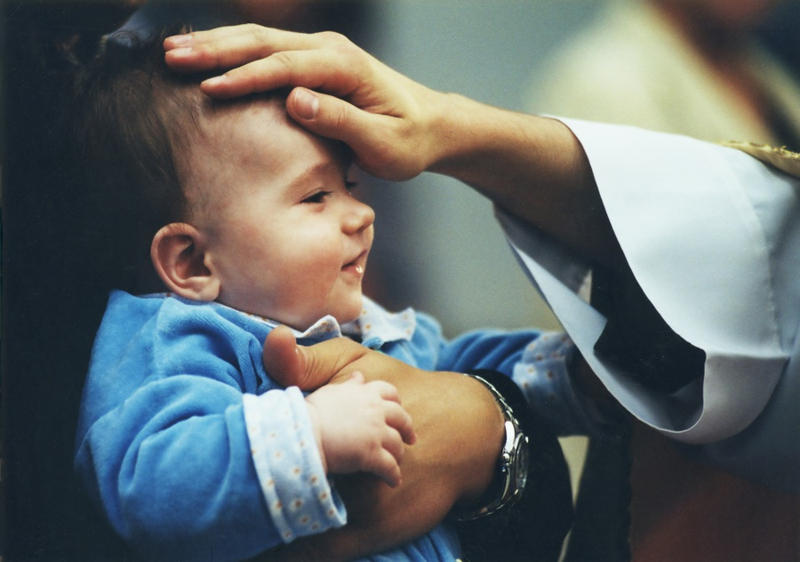

You
Your child
God
and the
Church

